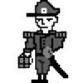
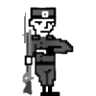
SECTION 1: SITUATION & ARMY STRUCTURE (table overlay & army build with points & date of battle).

SECTION 2: MISSION / GOAL / BRIEF (how the game was supposed to go).

SECTION 3: EXECUTION BY TURN/PHASE (how the game went with turns/phases noted if possible).

SECTION 4: OUTCOME / SUMMATION / DEBRIEF (objectives achieved/failed & casualties).

